1. What is a Computer?

- It is an electronic device that manipulates information or data. It has the ability to store, retrieve, and process data.

2. What are the essential parts of a Computer?

* Motherboard
* Central Processing Unit (CPU)
* Graphical Processing Unit (GPU)
* Random Access Memory (RAM)
* Storage device
* Processor
* Power Supply
* Circuit Board

3. Who are the notable inventors of hardware and software? Site at least (5) software developers and (5) Hardware developers.

**Hardware:**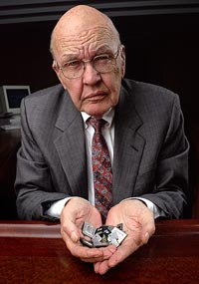

1. Jack Kilby - Developer of the first integrated circuit which revolutionized the design and production of electronic devices, including computers.

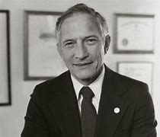

1. Robert Noyce - Co-inventor of the integrated circuit and developer of the microprocessors at Intel.



1. Steve Wozniak - Co-founder of Apple Inc. and developer of the Apple I and Apple II computers.

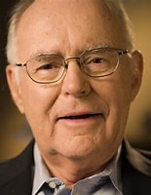

1. Gordon Moore - Co-founder of the intel and developer of microprocessor technology, known for Moore's Law.

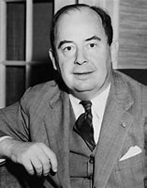

1. John von Neumann - Developer of the architecture for modern computers, knwn as von Neumann architechture.

**Software:**

1. Guildo van Rossum - Creator of Python programming language, a versatile widely used programming language known for simplicity and readability.



1. Dennis Ritchie - Creator of the C programming language and co-developer of the Unix operating system.



1. - Developer of C++, an extension of C that introduced object-oriented programming.



1. Guido van Rossum - Developer of the Java programming language, which is platform-independent and widely used in enterprise software.

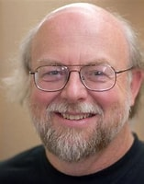

1. James Gosling - Creator of the Linux kernel, which is the core of the Linux operating system.

**References: (APA 7th Edition/IEEE)**

1. Dennis, M. A. (2024, June 16). Jack Kilby | Nobel Prize-Winning engineer & inventor. Encyclopedia Britannica. <https://www.britannica.com/biography/Jack-Kilby>
2. Introduction | The Man behind the Microchip: Robert Noyce and the Invention of Silicon Valley | Oxford Academic. (n.d.).<https://academic.oup.com/book/2113/chapter-abstract/142051014?redirectedFrom=fulltext>
3. Dennis, M. A. (2000, November 17). Gordon Moore | Biography & Facts. Encyclopedia Britannica. <https://www.britannica.com/biography/Gordon-Moore>
4. Admin, C. W. (2023, July 27). Steve Wozniak: Inventor and Apple co-founder. Berkeley Engineering.<https://engineering.berkeley.edu/steve-wozniak-inventor-and-apple-co-founder/>
5. Poundstone, W. (2024, August 2). John von Neumann | Biography, Accomplishments, Inventions, & Facts. Encyclopedia Britannica.<https://www.britannica.com/biography/John-von-Neumann>
6. Computer History Museum. (2021, February 10). James Gosling - CHM. CHM.<https://computerhistory.org/profile/james-gosling/>
7. Computer History Museum. (2021a, February 10). Guido van Rossum - CHM. CHM.<https://computerhistory.org/profile/guido-van-rossum/>
8. Jorgecardete. (2024, February 5). Guido van Rossum: The creator of the python programming language. Medium.<https://medium.com/thedeephub/guido-van-rossum-the-creator-of-the-python-programming-language-b85a7db3e8a0>
9. Computer History Museum. (2021a, February 10). Bjarne Stroustrup - CHM. CHM.<https://computerhistory.org/profile/bjarne-stroustrup/>
10. Inductee Dennis Ritchie, who invented Unix, transformed technology. (2024).https://www.invent.org/inductees/dennis-ritchie